Peer Review Process

Assembled team with roles report

Module | Programmer Name | Due Date | Actual Date Completed
server.py | Benson | 3/03/12 | - changed to networking.py, incomplete
bg_waves.py | Brian | 16/04/12 | 12/03/12
client.py | Brian | 3/03/12 | - changed to networking.py, incomplete
message_panel.py | Brian | 3/03/12 | 03/03/12
mousehitbox.py | Brian | 3/03/12 | 01/03/12
upgrade.py | Brian | 16/03/12 | 16/03/12
creditsscreen.py | Brian | 16/04/12 | 10/03/12
introscreen.py | Brian | 16/04/12 | 10/03/12
joinscreen.py | Brian | 16/04/12 | 12/03/12
lobbyscreen.py | Brian | 3/03/12 | 03/03/12
mainscreen.py | Brian | 16/04/12 | incomplete
screen.py | Brian | 3/03/12 | 28/02/12
action.py | Brian, Matt | 3/03/12 | 26/02/12
unit.py | Matt, Brian | 20/03/12 | 16/03/12
gamescreen.py | Matt, Brian | 16/04/12 | incomplete
shopscreen.py | Matt, Brian | 10/03/12 | 10/03/12
upgradescreen.py | Matt, Brian | 16/03/12 | 14/03/12
board.py | Matt | 20/03/12 | 18/03/12
constants.py | Matt | 10/04/12 | incomplete - constantly being updated
defense.py | Matt | 20/03/12 | 23/03/12
offense_panel.py | Matt | 4/03/12 | 15/03/12

Inspection Error List

System: Networking
Subsystem: networking.py
Module Name: networking.py
Moderator: Benson
Inspection Type: Code

Location | Error Description | Error Type | Error Class | Sev-irity
 | No ability to send network data (for example, messages) longer than 255 characters | Functionality | M | Minor
20 | TODO message remains even after it has been done | Documentation | E | Minor
38 | Closed connection could be polled for info which could cause an I/O error | Logic | W | Major
77-82 | Bad way to parse for text, can be cleaned up and made more efficient | Standards | W | Minor
83-85 | Old code is commented out rather than removed | Documentation | E | Minor
121 | Can set a slot to AI or closed even if it has a player in it, instead of kicking player and closing connection first | Functionality | W | Minor
143 | Unindented statement allows anyone to start game | Syntax | W | Major
143 | Unindented statement only checks to see if everyone is ready if that player is not the host | Syntax | W | Major
36,107,  113, 140 | has_key is used although "in" is used in the rest of the code | Standards | W | Minor

Inspection Summary

System: Networking
Subsystem: networking.py
Module Name: networking.py
Moderator: Benson
Inspection Type: Code
MINOR ERRORS
Error | Missing | Extra | Wrong | Total
Interface | 0 | 0 | 0 | 0
Data | 0 | 0 | 0 | 0
Logic | 0 | 0 | 1 | 1
Input/Output | 0 | 0 | 0 | 0
Syntax | 0 | 0 | 0 | 0
Performance | 0 | 0 | 0 | 0
Human Factors | 0 | 0 | 0 | 0
Standards | 0 | 0 | 2 | 2
Documentation | 0 | 2 | 0 | 2
Other | 0 | 0 | 0 | 0

MAJOR ERRORS
Error | Missing | Extra | Wrong | Total
Interface | 0 | 0 | 0 | 0
Data | 0 | 0 | 0 | 0
Logic | 0 | 0 | 1 | 1
Input/Output | 0 | 0 | 0 | 0
Syntax | 0 | 0 | 2 | 2
Performance | 0 | 0 | 0 | 0
Human Factors | 0 | 0 | 0 | 0
Standards | 0 | 0 | 0 | 0
Documentation | 0 | 0 | 0 | 0
Other | 0 | 0 | 0 | 0

Inspection Report

System: Networking
Subsystem: networking.py
Module Name: networking.py
Moderator: Benson
Size of material: 220 lines
Inspection Meeting Number: 1
Inspection Duration: 1hr
Number of Inspectors: 3
Total Preparation Time: 20 minutes
Unit Disposition: Meet
Estimated rework effort: 2 hours
Rework to be completed by: Matt
Reinspection scheduled for: 1 week
Other inspectors: Matt, Brian
Date: March 8, 2012
Additional Comments: There are probably errors that aren't visible just by looking at the code. These will manifest themselves upon testing.

Test Case: mousehitboxes
Mousehitboxes is an interesting test case as it clearly shows the automated testing process of python's unittest package. We use mousehitboxes for any clickable space on the screen - buttons, units, menu options, etc. We needed to test that these boxes would behave as expected when putting them down in all sorts of combinations. Using unittest this is fairly easy to do, as we explained in the Design Document (Section 5.3).

Implementation:
This test case was implemented using the automated unittest package in python. This package allows for writing classes that run whenever the python script they are contained in is run. This means that we wrote a class, TestMouseHitboxes, inside mousehitbox.py. This class is run every time mousehitboxes.py is used (which is frequently throughout the rest of the code of Conquer the Seas).
This is a black-box test case: it does not take into account the code of mousehitboxes.py. It simply tests that hitboxes are correctly applied in all possible real-world scenarios. It positions hitboxes on top of each other, near each other, and in every other possible scenario. For example, the following code tests what happens when two boxes are partially inside one another on the same layer:
def test_half_inside(self):
with self.assertRaises(AttributeError):
self.mh.append((0, 1, 2, 2), self.function(0))
self.mh.append((1, 0, 2, 4), self.function(1))
When mousehitboxes is run, this method is called, along with all other methods that begin with "test_". If it raises AttributeError, it will return true, if it does not, it will return false, and the test will fail. This is just one example of inputs and expected outputs. The following table lists all the inputs and expected outputs.

Input and Output

Input | Output
Two hitboxes in the same place, same layer, click simulated in center | AttributeError is raised, true is returned
Two hitboxes in the same place, on different layers, click simulated in center | Top box is clicked on, true is returned
Two hitboxes in same place, layered in different order, click simulated in center | Top box is clicked on, true is returned
Two hitboxes, one partially inside the other, default layer (same layer) | AttributeError is raised, true is returned
Two hitboxes, one partially inside the other, set to same layer | AttributeError is raised, true is returned
Two hitboxes, one partially inside the other, on different layers. Clicks simulated inside each, and on overlapping area | Correct box is clicked on for each case, true is returned each time
Two hitboxes, one partially inside the other, on different layers, opposite order as previous. Clicks simulated inside each, and on overlapping area | Correct box is clicked on for each case, true is returned each time
Two hitboxes, one with its corner inside another on the default level | AttributeError is raised, true is returned
Two hitboxes, one with a different corner inside another on the default level | AttributeError is raised, true is returned
Two hitboxes, one contained entirely within another on the same default layer | AttributeError is raised, true is returned
Four hitboxes, all layered on top of each other, in decreasing size | Correct box is clicked on for each case, true is returned each time
Three hitboxes, on three different layers, all slightly overhanging each other | Correct box is clicked on for each case, true is returned each time
Two hitboxes in a cross formation on the same layer | AttributeError is raised, true is returned
Two hitboxes in a cross formation on the same layer, cross in opposite direction | AttributeError is raised, true is returned
Two hitboxes, close but not touching, six different orientations - this is to check overlap math | No errors raised, true is returned

Log Results

Because one of our coding practices is to only commit and push new changes if all test cases are passed, there was no point in time where committed code failed tests. As such, to show what failed test results look like, a trivial change was made to cause a test to fail. Here is what the results of the test look like when a test is failed:
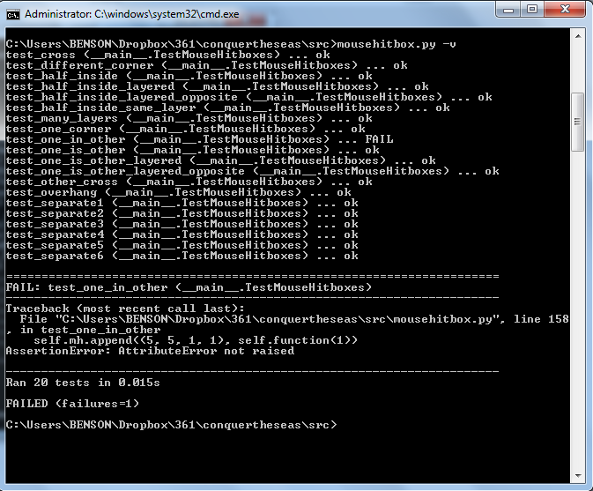
Each test is listed along with its result. As seen in this image, test_one_in_other has failed. The line which fails is shown, and the AssertionError is given - in this case, AttributeError was not raised when it was expected to. This means that two boxes were allowed to be placed in an overlapping formation that was not allowed. We would have to go back to where we raise AttributeErrors and make sure that we're raising them properly for box overlaps that should not be allowed.

After having fixed this error, we run mousehitbox.py again, and we see that all tests have been passed.
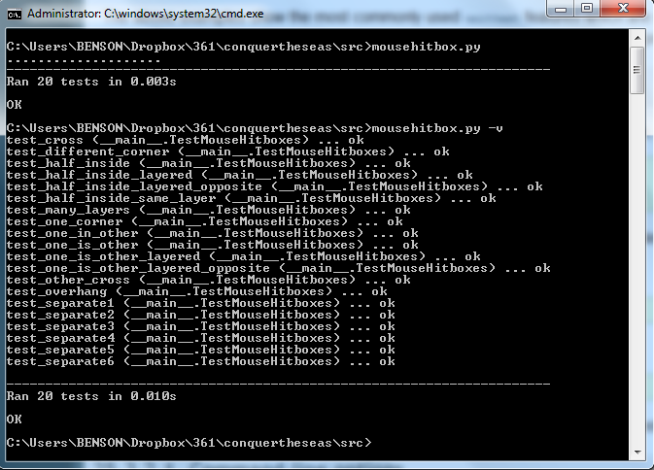
Now that all test cases have been passed, we can be sure that any and all changes to mousehitbox are acceptable and no functionality has been compromised.

Log Corrections and Regression Changes
Again, because of our practice of not committing code that failed tests, we do not have a place we can revert back to where we had errors in this code that caused it to fail tests. However, we can list the changes and revisions that took place to mousehitbox.py.
Date | Change
11/12/11 | modulized, credits added, clickbox deletion added
11/12/11 | fixed unittests
11/12/11 | more hitbox test fixes
09/01/12 | moved to a different location
19/01/12 | hitbox reworking begins - tests for one inside the other added
20/01/12 | one inside another is no longer allowed
01/02/12 | multi-level clickboxes are allowed, test cases for them added, and all test cases still pass
02/02/12 | tests for different boxes inside one another added
02/02/12 | slicing makes new indices - test cases still all pass
02/02/12 | minor comment change
16/02/12 | added a way to clear a set of mousehitboxes
18/03/12 | mouse functions now only take mpos, not scr - test cases all still pass

Each of these changes was only committed once all mousehitbox tests passed.

Modification Log
This table shows the changes that have been made since earlier documents.
Title | Description | Date | Responsible | Results/Changes
Client/Server.py | Client.py and server.py merged into networking.py | 02/03/12 | Matt | More compact networking code, all in one place
Due dates | Most important features were given earliest due dates, despite being the most difficult to complete | -- | Benson, Matt, Brian | Many deadlines were missed as code that was intended to be finished was not complete.
Networking completed before single-player AI | Networking code was completed before single-player AI. | -- | Benson, Matt, Brian | Single-player AI was given a lower priority
Test Driven Development | Many areas of the code (such as networking and GUI) are very difficult to write tests for before writing any code. | -- | Benson,  Matt, Brian | Testing for some classes will take place manually after code has been written.
UpgradeFactory removed | UpgradeFactory has been abandoned in favor of using a hard-coded dictionary that can generate upgrade trees. | 16/03/12 | Brian | A hard-coded dictionary of upgrades needs to be created

Programmer's Journal

Benson's Journal

March 1st
Wrote up the deliverables document and the programmer responsibility table to turn in. Committed it, but I don't think we'll need it later.
March 2nd
Worked on a new server in python. learned a lot about servers, i've never done server stuff in python before. this way seems much easier than the previous way my teammates wrote.

March 9th
Fixed some hitbox issues on the main screen. Also, made it so you can change your multiplayer name. Because I spent so much time writing documents the first half of the year, I'm behind on the code. I don't think I'd like working somewhere that needed so many documents, I much prefer a more code-first fix-later style.

March 10th
Made name changing for multiplayer work. Also, you can now host and join games without race conditions ever being an issue. Networking stuff is pretty easy to have problems with.

March 11th
Names can now have spaces - before, they were just regarded as invalid. Names also will scroll appropriately if you enter a name that's too long. Also changed some mousehitbox issues on the new game submenu.

March 13th
Made upgrade screen have a back button that works. Drew lines to partition the buying and info display section of the upgrade screen.
Later on, made a shop button that works for upgrade screen. The ship 1, 2, and 3 buttons also change between the different upgrade trees (one set for each ship). Right now that just means switching the background color, because we don't actually have different trees.

March 16th
Made upgradeIdeas.txt - a list of ideas for how to do our upgrades and generate the trees. Hopefully this will be used to discuss this, maybe not, we'll see.

March 17th
Made the purchase button on the shop gray out if you can't afford the thing you've selected. I also made upgrades purchasable. They don't actually do anything yet, but the trees make sure you have enough experience and the prerequisite upgrades purchased before allowing you to buy them. This is actually pretty fun to code.

March 23rd
Sent some emails about the implementation document. Made terrain generation. It's really bad and random right now, but the ideas are all down. Also made coins that float through the water that the defensive units can collect, right now they just kill the defensive units.

March 30th
Finishing up the implementation document as it's due tomorrow. I still really don't like writing documents, I feel like they just take away from the coding. Maybe just planning out some general structure early on?

